**TASK 1:**

1.Write terraform script to import functionality to manage existing infrastucre resources  
Assume you have u have existing aws s3 bucket name xyz(name)  
Task: i have write terraform configuration file to manage existing s3 bucket.

I have created s3 bucket in console and importing with this configuration files,

**Main.tf**

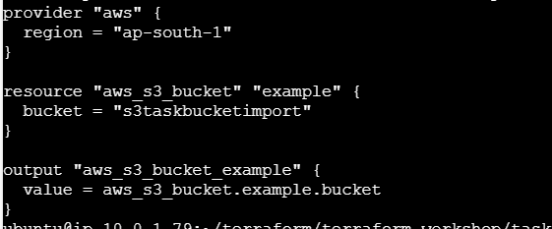

**Import.tf**

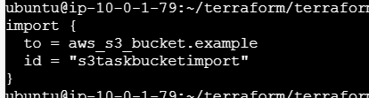

Terraform validate

Terraform init

Terraform plan

Terraform apply

**TASK 2:**

2. Write terraform script to create an AWS security group with Dynamic Ingress Rules

**Main.tf**

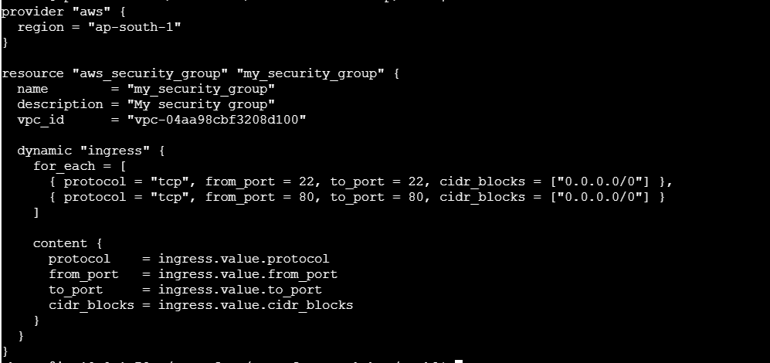

Terraform validate

Terraform init

Terraform plan

Terraform apply

This Terraform script sets up an AWS provider in the ap-south-1 region and creates a security group named my_security_group in a specified VPC. It dynamically adds ingress rules to allow SSH (port 22) and HTTP (port 80) access from any IP address. The dynamic block iterates over the defined ingress rules to apply them to the security group.

Benefits using dynamic block:

* **Scalability**: Easily add more rules in the future by updating the list in the for_each block.
* **Maintainability**: Reduces redundancy and makes the script cleaner and easier to manage.
* **Flexibility**: Modify rules by changing values in the list, making it adaptable to different requirements.